ONLINE WRITING PLATFORM (STUDY LINK)

CYNTHIA JERUTO KIPTOON

A research project submitted to the school of science, engineering and technology in partial fulfilment of the requirements for the award of Diploma in Information technology, Kabarak university

July, 2025

COPYRIGHT
️2025
All rights reserved
No part of this project may be reproduced, stored in any retrieval system or transmitted in any form or by any means, electronic, mechanical, photocopying and recording without prior written intention of the author Kabarak University.
Sign: ____________ Date: ___________

DECLARATION AND APPROVAL
I declare that this work without reasonable doubt has been presented before to the faculty of Information Technology or any other institution. No part of this research document shall therefore be duplicated without prior consent.
Sign: ______________ Date: __________
Student: Cynthia Jeruto Kiptoon
Registration number: DIT/N/1060/05/24

RECOMMENDATION
This research project entitled Online Writing Platform (Study link) written by Cynthia Jeruto Kiptoon is presented to the School of Science, Engineering and Technology, Kabarak University. I have reviewed this project and recommended that it will be accepted in partial fulfillment of the requirements for the Diploma in Information Technology.
Signature: _______________ Date: ____________
Mr. Elvine Saikwa,
School of Science, Engineering and Information Technology,
Kabarak University.

ACKNOWLEDGEMENT
I thank God for the gift of life, family, friends and provision without which I would not have made it this far in my academic pursuits. My sincere gratitude goes to my supervisor, Mr. Elvine Saikwa, for his guidance and support during this project. I also appreciate my lecturers and colleagues for their assistance and encouragement.
I am grateful to all students who participated in the surveys and interviews that made this study possible. Finally, I would like to thank my family for their patience and support.

DEDICATION
This project is lovingly dedicated to my family and friends who supported me throughout this academic journey. Their encouragement and belief in me have been invaluable.

ABSTRACT
The Online Writing Platform (Study Link) is a web- based system designed to connect student who require academic writing assistance with peers who offer writing and research services. The platform enables secure communication, task posting, bidding, delivery, and feedback mechanisms. Study link aims to provide students with income generating opportunities while insuring quality, transparency and accountability in academic collaborations

Table of Contents
COPYRIGHT ii
DECLARATION AND APPROVAL iii
RECOMMENDATION iv
ACKNOWLEDGEMENT v
DEDICATION vi
ABSTRACT vii
LIST OF TABLES xi
LIST OF FIGURES xii
INTRODUCTION 1
CHAPTER ONE 1
1.0 Background 1
1.1 Statement of the problem 2
1.2 Purpose of the study 2
1.3 Objectives of the Study 2
1.4 Research questions 3
1.5 Justification of the study/significance of the study 3
1.6 Scope of the study 3
1.7 Limitation of the study 4
1.8 Assumptions of the study 4
CHAPTER TWO 5
LITERATURE REVIEW 5
2.0 Introduction 5
2.1 Academic Performance and the Challenge of Time Poverty 5
2.2 Theoretical Frameworks 5
2.2.1 Self-Regulated Learning (SRL) Theory 5
2.2.2 Cognitive Load Theory (CLT) 6
2.3 Existing Academic Support Tools and Their Gaps 6
2.4 Conceptual Framework: StudyLink System Flow 7
CHAPTER THREE: 9
RESEARCH METHODOLOGY 9
3.0 Introduction 9
3.1 System Development Methodology 9
3.1.1 Requirement’s Analysis 9
3.1.2 Design 10
3.1.3 Develop 10
3.1.4 Testing 10
3.1.5 Maintenance 10
3.1.6 Feedback 11
3.2 Justification of Methodology 11
1.2.1 Functional Requirements (FR) 11
3.3 Non-functional requirements (NFR) 12
3.4 Tools and Techniques 12
3.4.1 Visual Studio Code (VS Code) 13
3.4.2 HTML/JavaScript/Tailwind CSS 13
3.4.3 Google Gemini API 13
3.4.4 Firebase Fire store 13
3.4.5 Firebase Authentication 13
3.4.6 UML/DFD Tools 13
3.5 Milestones and Deliverables 13
3.5.1 StudyLink Core Platform 13
3.5.2 Administrator Module 13
3.5.3 Expert Consultation Panel 14
3.5.4 User Manual and Documentation 14
3.6 Data Collection Methods 14
3.6.1 Primary Data Collection Methods 14
3.6.2 Secondary Data Collection Methods 14
3.7 Data Flow Diagram 14
3.7.1 Context Diagram (Level 0) 14
15
15
15
3.7.2 DFD Diagram (Level 1) 15
CHAPTER FOUR: 16
SYSTEM ANALYSIS, IMPLEMENTATION AND DESIGN 16
4.0 Introduction 16
4.1 Input Design 16
4.1.1 User Login Screen 16
4.1.2 New Assignment Submission Form 17
4.1.3 Dashboard Screen 17
4.2 Description of the Implementation 18
4.2.1 Hardware Specification 18
4.2.2 Software Specification 18
4.3 Description of Testing and Results 19
4.3.1 System Testing 19
4.3.2 Testing and Data results 19
4.3.3 Non-functional requirements 19
4.4 Description of results 20
CHAPTER FIVE: 21
CONCLUSION AND RECOMMENDATION 21
5.0 Introduction 21
5.1 Conclusion 21
5.2 Recommendation 21
5.3 Future Works 22
REFERENCES 23
APPENDICES 24
APPENDIX A: CODE REPOSITORY AND TECHNICAL ARTIFACTS 24
GITHUB RESPIROTORY LINK ACCES 24

LIST OF TABLES
Table 4 1: Testing and Data Results 26
Table 4 2: Non-functional requirements 26

LIST OF FIGURES
Figure 1: Conceptual Framework 8
Figure 2: Agile Methodology 9
Figure 3:Context Diagram (Level 0) 15
Figure 4 :DFD Diagram (Level 1) 15
Figure 5: User Login Screen for STUDYLINK 16
Figure 6: New Assignment Submission Form for STUDYLINK 17
Figure 7: Student Dashboard Screen for STUDYLINK 18

INTRODUCTION
This chapter outlines the foundation of the research project, addressing the critical issue of supporting university students who seek flexible employment opportunities alongside their academic studies. The proposed solution is an online platform named Studylink. This section highlights the key contents of the chapter, including the background of the study, Statement to the problem, Purpose and Objectives, Research questions, Justification for the Study, Scope, Limitations and Assumptions of the study

CHAPTER ONE

1.0 Background
The modern global economy is increasingly characterized by the rise of the “gig economy” and digital platforms, making flexible, remote work more accessible than ever before. This shift has profoundly impacted university students, many of whom must balance their strenuous academic demands with the need to earn income for tuition, living expenses and personal development. Data indicates that a significant percentage of the student population is actively engaged in part-time jobs, freelance gigs, or running small side businesses to support themselves. This is desire for financial independence is often coupled with the pursuit of gaining vital work experience and practical skills that enhance their post-graduation employability
However, students face unique challenges in their endeavor. General online jobs boards are rarely tailored to the student lifestyle, offering inflexible hours, non-vetted opportunities or requiring commitments that clash with academic schedules. Furthermore, many students-run businesses or services rely on fragmented, informal methods of promotion- such as social media groups or instant messaging –which lack a formal system for insecure transactions, service authentication and schedule coordination. This fragmentation can lead to poor time management, increased stress, potential exposure to unreliable clients and ultimately a decline in academic performance. Studylink is proposed to bridge this gap by creating a dedicated digital ecosystem that is inherently designed to accommodate the unique flexibility and security needs of the working students.
The purpose of this it to design and implement a functional prototype of Studylink: an online writing platform that connects students offering academic writing services will enhance collaboration, create income opportunities and foster digital literacy among students.

1.1 Statement of the problem
The problem this study addresses is the lack of a systematic, secure and student-centric online platform that efficiently connects university students to flexible side-jobs and freelancing opportunities tailored to their academic calendars
Currently, students seeking side jobs must navigate scattered, non-university specific platforms, which frequently exposes them to three core issues: incompatible schedules. Leading to a direct conflict between work and class attendance; low security and reliability, resulting from a lack of user vetting, which exposes students to fraudulent or unreliable clients; and poor opportunity visibility, where students are often unaware of flexible gigs within the university levels, and limited participation in relevant, skill-building opportunities. Consistently, there is a dire need to design and implement a dedicated digital solution, which this project names Studylink, that standardizes and centralizes this job-seeking process to mitigate the negative impacts on students’ academic performance and well-being.

1.2 Purpose of the study
The purpose of this study is to design, develop, and evaluate an interactive online platform, Studylink, that effectively connects university students to flexible, authenticated side-job and freelancing opportunities, thereby enabling them to earn income while effectively managing and protecting their academic commitments.

1.3 Objectives of the Study
The study will be guided by the following specific objectives:
- To investigate and identify the specific types of online and flexible side jobs must suitable for university students and the corresponding work-study challenges they encounter
- To design a comprehensive, user-friendly system architecture for the Studylink platform, incorporating essential features such as flexible job filter, time management tools, and a student/client rating system.
- To develop and implement a functional prototype of the proposed online platform, Studylink, using appropriate web development and database technologies
- To evaluate the effectiveness, efficiency and overall usability of the implemented platform, Studylink, in successfully matching students with side-job opportunities and improving their work-study balance

1.4 Research questions
The study will seek to answer the following research questions:
- What are the preferred types of flexible side jobs for university students and that are the primary challenges they face when seeking and managing these opportunities?
- What are the essential features and design specifications required for an effective and student-centric online platform like Studylink to support work-study balance?
- How can the Studylink platform be successfully developed and implemented to connect students with side-jobs opportunities?
- How effective and usable is the implemented online platform, Studylink, in matching students with flexible side jobs and helping them manage their work-study balance, according to user feedback?

1.5 Justification of the study/significance of the study
This study holds significantly value for several stakeholders:
- For students: Studylink will provide a centralized, secure and flexible tool to find income- generating opportunities, helping alleviate financial stress while gaining essential career-related skills and experience without sacrificing their academic success.
- For Academia and Future Research: the study contributes a vital blueprint for developing specialized digital platforms in the education sector. It offers empirical data on the efficacy of the student population.
- For Employers and local community: the platform provided a reliable and vetted source of part-time, project-based talent, particularly for small businesses and start-ups, offering access to a highly competent and motivated student workforce

1.6 Scope of the study
This study focuses on the design and functional prototype implementation of the web-based online platform, Studylink, specifically for connecting currently enrolled university students with short-term, flexible side jobs and freelance tasks. The platform’s scope is limited to the functionalities needed to facilitate job posting, student profile creation, job matching and basic communication. It does not extend to the full financial management features (e.g., direct payroll or advanced invoicing) or the administration of traditional, full time campus employment

1.7 Limitation of the study
The following potential weaknesses or constraints are acknowledged:
- Network and digital divide: the project’s effectiveness depends on student’s consistent access to reliable internet connection and modern smart devices. This is mitigated by designing the Studylink platform to mobile-first and optimized for lower bandwidths where possible.
- Security depth: due to time and resource constraints for a prototype, the Studylink platform will implement basic security measures (e.g., user authentication), but advanced, enterprise-level security features may be beyond the scope of this initial development.
- Generalizability: the evaluation phase may be conducted with a limited number of students and employer participants, which may affect the generalizability of the findings to the entire national student population.

1.8 Assumptions of the study
- The successful completion and relevance of this study are based on the following assumptions:
- Digital Literacy: it is assumed that the target student population possess the basic level of digital literacy required to navigate and effectively utilize the Studylink platform
- Data integrity: it is assumed that the data provided by the students and employers during the platform’s testing and evaluation phase is truthful and reflects their actual experiences and needs.
- Existence of Demand: it is assumed that there is aa sufficient, continuous supply of relevant, flexible side jobs opportune

CHAPTER TWO

LITERATURE REVIEW

2.0 Introduction
This chapter establishes the academic context for the StudyLink platform by analyzing the difficulties faced by university students who manage both demanding academic assignments and concurrent side jobs. It reviews the theoretical foundations (such as time management and cognitive load) that underpin the system's design, critiques the general gaps in existing academic support tools, and presents the conceptual framework for StudyLink.

2.1 Academic Performance and the Challenge of Time Poverty
The modern university student often engages in part-time or full-time employment to finance their education, a phenomenon that introduces a significant trade-off between economic necessity and academic performance. The primary challenge is not a lack of effort, but time poverty, which directly impacts the quality of academic output. Writing complex assignments—such as research papers and essays—requires significant cognitive resources and dedicated, uninterrupted blocks of time, often referred to as "deep work" (Newport, 2016). When students must rush assignments between work shifts, the following academic deficiencies are consistently observed:
Superficial Analysis: Lack of time prevents the critical reading and synthesis necessary for deep analytical thought.
Organizational Breakdown: Drafting is rushed, leading to poor structural coherence and weak topic sentence flow.
Increased Stress and Fatigue: The constant context-switching between work and study responsibilities increases extraneous cognitive load, diminishing the mental capacity available for the actual task (Sweller, 2010).

2.2 Theoretical Frameworks
The design of the StudyLink platform is guided by established learning and cognitive theories, ensuring the system provides meaningful, psychologically sound assistance.

2.2.1 Self-Regulated Learning (SRL) Theory
SRL emphasizes a student's ability to monitor, control, and regulate their own learning process. Key components include goal setting, strategic planning, and self-monitoring (Zimmerman, 1990). Working students often struggle with the strategic planning phase because external work constraints disrupt traditional scheduling.
StudyLink's Role: The Dynamic Scheduling Algorithm (FR1) serves as an external planning mechanism, helping the student set realistic goals and generate actionable "Deep Work Blocks (DWB)" that align with their actual availability, thereby supporting the planning and strategic aspect of SRL.

2.2.2 Cognitive Load Theory (CLT)
CLT suggests that working memory has a finite capacity. In an overloaded student, memory is consumed by Extraneous Cognitive Load (effort spent managing non-essential tasks, like switching between a calendar, a citation tool, and a drafting application).
StudyLink's Role: The platform's One-Screen Workflow (NFR1) is a direct implementation of CLT principles. By integrating scheduling, drafting, AI assistance, and integrity checks into a single interface, StudyLink minimizes extraneous load, freeing up cognitive resources for Intrinsic Cognitive Load—the critical thinking required for high-quality writing.

2.3 Existing Academic Support Tools and Their Gaps
The current market offers various fragmented tools, but none adequately address the integrated challenges faced by the working student. Generic scheduling applications (such as calendar or to do apps) serve as basic reminders but lack the intelligence to incorporate complex, fixed external constraints like work-shift schedules, rendering them ineffective at finding optimal, cognitively-ready time slots for deep academic work. Furthermore, writing-specific aids, such as grammar and style checkers, are primarily reactive, focusing narrowly on mechanical issues like spelling and punctuation after the drafting is complete. Similarly, tradition plagiarism and originality checkers only identify issues post-submission, failing to offer the proactive, real-time citation assistance needed to prevent academic integrity errors in the first place. While unethical essay writing services exists, they offer a complete lack of student ownership and violate academic policy.
The critical gap in the existing ecosystem is the lack of a single, integrated system that proactively manages the students’ time constraints while providing simultaneous, high-context quality assurance throughout the entire writing process. This fragmentation compounds to students’ existing cognitive load, which Studylink is designed to solve.

2.4 Conceptual Framework: StudyLink System Flow
The conceptual framework, illustrated in Figure 1, provides a high-level visual representation of how the StudyLink platform processes input, applies its core intelligence, and delivers actionable outputs to the working student.
The system is initiated when the Working Student provides two primary inputs: their Fixed Work Schedule (the external constraint) and Academic Assignment Parameters (the task constraint). These inputs are stored in the database.
The data then flows into the system's core intelligent modules:

USER
(students)

O

INPUT
Service request
OUTPUT
Service offered

PROCESS
Matching engine
PROCESS
Service delivery

OUTPUT
Task assignment
OUTPUT
Completion record

PROCESS
Review& rating
PROCESS
Payment processing

USER
(Platform Admin)

Figure 1: Conceptual Framework

CHAPTER THREE:

RESEARCH METHODOLOGY

3.0 Introduction
This chapter details the research and development approach used for the StudyLink platform. It outlines the system development methodology, justifies its selection, and defines the system's functional and non-functional requirements to provide a clear understanding of the development process.

3.1 System Development Methodology
The methodology adopted for the development of the StudyLink platform is the Agile Methodology, specifically using the Scrum framework. Agile provides a flexible, iterative approach where requirements and solutions evolve incrementally through constant collaboration between the development team and end-users (the students and academic experts). This is essential for a system involving complex AI integration and user-specific scheduling needs, which are prone to evolving requirements.
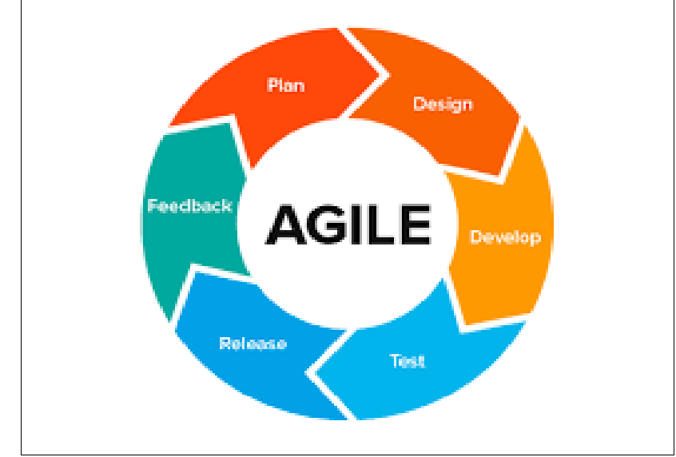
Figure 2: Agile Methodology

3.1.1 Requirement’s Analysis
The system requirements for StudyLink were gathered through structured interviews and questionnaires targeting working students, focusing on their pain points related to time poverty, stress, and academic integrity challenges. Key insights revealed the necessity of a tool that not only organizes time but also provides real-time, context-aware writing assistance. The requirements were categorized into two main groups: Functional Requirements (FR), which define specific system features, and Non-Functional Requirements (NFR), which dictate the quality attributes, such as performance and security.

3.1.2 Design
The design phase focused on creating a minimalist, one-screen workflow (NFR1) to directly minimize extraneous cognitive load, as discussed in Chapter Two. The architecture was designed to be modular, separating the scheduling component from the AI drafting component, allowing for independent development and testing. The primary design objective was a clean, intuitive User Interface (UI) suitable for quick interaction between work shifts.

3.1.3 Develop
Development was executed in short, time-boxed sprints using a modern, scalable web stack. Each sprint delivered a potentially shippable increment of the product. The core modules—the user authentication system, the Dynamic Scheduling Algorithm, and the AI Drafting Module (integrating the Gemini API)—were built sequentially. Development focused heavily on the back-end logic necessary for the time-slot optimization and the integration of the Language Model for real-time writing feedback.

3.1.4 Testing
Testing was conducted iteratively at the end of each sprint. Unit testing ensured individual components (e.g., the scheduling algorithm's accuracy). Integration testing verified seamless communication between the front-end interface and the Gemini API for prompt generation and response handling. Finally, User Acceptance Testing (UAT) involved actual working students testing the platform to validate that the Deep Work Blocks generated were truly usable and that the AI assistance improved writing quality efficiently.

3.1.5 Maintenance
Maintenance is conceptualized as a continuous process guided by post-deployment feedback. This involves monitoring system stability, particularly the performance of the AI endpoints, applying necessary patches, and executing minor feature enhancements based on user data.

3.1.6 Feedback
The feedback phase is continuous, integrated into the Agile framework. It involves collecting user metrics on feature usage, conducting periodic student surveys on the platform's effectiveness in reducing writing time, and gathering ratings on the quality of the AI-generated feedback and the human expert consultations (FR4).

3.2 Justification of Methodology
The Agile Methodology is justified because the requirements for an academic support tool are inherently dynamic. The iterative approach allows for:
Rapid Adaptation: Minor objective changes—such as updating the citation style logic or refining the AI prompt based on student performance data—can be implemented rapidly without major amendments to the overall schedule.
Risk Mitigation: Complex features, such as the AI module, are developed and tested early, ensuring the most challenging aspects of the system are stabilized quickly.
Client Collaboration: Constant feedback from student users ensures the system remains highly relevant to the dynamic constraints of the working student environment.

Functional Requirements (FR)
The functional requirements define the core capabilities of the StudyLink platform:
Dynamic Scheduling Algorithm: The system must analyze a user's pre-defined work schedule and assignment deadlines to automatically generate and reserve optimal, interruption-free 'Deep Work Blocks' (DWBs) within the user's platform calendar.
AI-Assisted Drafting Module: The system must utilize the Gemini API to provide real-time, context-aware suggestions directly within the drafting interface, focusing on improving argument coherence, thesis strength, and tone.
Academic Integrity Suite: The system must offer real-time, in-context citation generation supporting common academic styles (e.g., APA, MLA) and provide an on-demand originality check feature against external sources.
Expert Consultation Management: The system must allow users to securely schedule and manage asynchronous consultations with human academic experts, enabling draft upload, slot selection, and notification of expert feedback completion.
User Login and Authentication: The system must securely authenticate all users (students, experts, administrator) using custom token-based authorization to manage access and personalization.
Assignment Data Entry and Storage: The system must enable users to input, store, and reliably retrieve all assignment details (topic, word count, deadline, course), ensuring data persists across sessions and is accessible to the scheduling and drafting features.

3.3 Non-functional requirements (NFR)
The non-functional requirements define the quality attributes necessary for the system's success:
Usability (One-Screen Workflow): The system interface shall be intuitive, requiring no special training, with all critical tools (drafting, scheduling, AI feedback) accessible from a single dashboard view to minimize context switching.
Performance (AI Latency): The AI-Assisted Drafting Module (FR2) must deliver real-time feedback with a latency of less than 1.5 seconds to avoid disrupting the user's flow.
Reliability: The system shall maintain 99.9% uptime, and data related to Deep Work Blocks and assignment drafts must be backed up hourly to prevent loss.
Security: All user data (drafts, schedules, personal information) shall be encrypted both in transit (SSL/TLS) and at rest (Fire store security rules), ensuring robust protection from unauthorized access.
Scalability: The system architecture must be able to handle a 10x increase in concurrent users (working students) within a 12-month period without significant performance degradation.

3.4 Tools and Techniques
These are the technologies incorporated to build the functional StudyLink platform.

3.4.1 Visual Studio Code (VS Code)
Primary code editor for writing, editing, and debugging all front-end and back-end logic.

3.4.2 HTML/JavaScript/Tailwind CSS
Used for creating the dynamic, responsive, and aesthetically pleasing front-end interface, focusing on mobile-first design.

3.4.3 Google Gemini API
Acts as the core server-side intelligence for the AI-Assisted Drafting Module (FR2) and Academic Integrity Suite (FR3) to provide high-quality, real-time linguistic and contextual feedback.

3.4.4 Firebase Fire store
Serves as the database management system to securely store structured data, including user profiles, fixed work schedules, assignment parameters, and draft documents.

3.4.5 Firebase Authentication
Used to manage user sessions, sign-in, and authorization, securing access for students, experts, and administrators.

3.4.6 UML/DFD Tools
Used for visually modeling the system architecture and data flows during the design phase.

3.5 Milestones and Deliverables
This section elaborates on the planned outcomes and modules of the StudyLink project.

3.5.1 StudyLink Core Platform
The main deliverable is the fully functional web application. The core system will enable working students to manage their time (FR1) and generate high-quality, ethically sound academic essays (FR2, FR3).

3.5.2 Administrator Module
The proposed system includes an administrator module responsible for: managing user accounts, monitoring system performance and usage statistics (e.g., number of Deep Work Blocks generated), and checking the integrity of the database records related to expert consultation logs.

3.5.3 Expert Consultation Panel
This module is a dedicated interface for human academic experts (FR4) to securely access student drafts, provide timestamped feedback, and manage their consultation schedules and communications.

3.5.4 User Manual and Documentation
A comprehensive user manual will be provided, guiding students on how to input their work schedule, interpret AI feedback, and utilize the Dynamic Scheduling feature to maximize their deep work hours.

3.6 Data Collection Methods

3.6.1 Primary Data Collection Methods
Primary data collection was crucial for understanding the exact needs and workflows of the target user group. Close-ended questionnaires were utilized, distributed to a sample of university students known to hold concurrent employment, to collect quantitative data on their current time allocation, academic workload, and usage of existing tools. Furthermore, one-on-one structured interviews were conducted with a small group of students and academic advisors to gather qualitative data, identifying the extent and specific nature of their time management and writing struggles. The quantitative data informs the system requirements (FRs), and the qualitative data informs the design and usability (NFRs).

3.6.2 Secondary Data Collection Methods
Secondary data was collected from various sources, including academic journals and online articles, to establish the theoretical foundation of the project (as detailed in Chapter Two). This included research on Self-Regulated Learning (SRL), Cognitive Load Theory (CLT), and best practices in AI-assisted education technology to inform the design of the core algorithms.

3.7 Data Flow Diagram

3.7.1 Context Diagram (Level 0)
A context diagram is the highest-level view of the information system, illustrating StudyLink as a single process interacting with external entities.
StudyLink
Shared link system
STUDENT
WRITER
Assignments

Completed work

Confirmation payment request
Payment system

Figure 3:Context Diagram (Level 0)

3.7.2 DFD Diagram (Level 1)
The DFD Diagram (Level 1) breaks down the main processes within the StudyLink system, showing the flow of data between key modules and the central database.
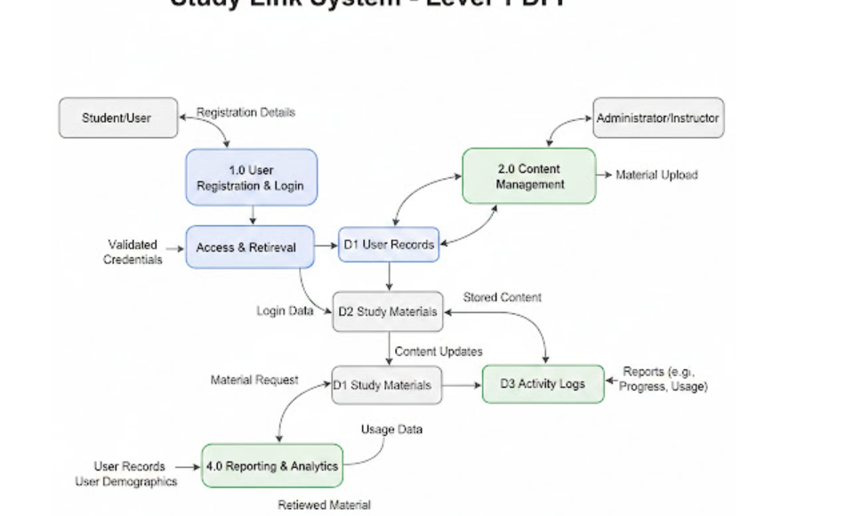
Figure 4 :DFD Diagram (Level 1)

CHAPTER FOUR:

SYSTEM ANALYSIS, IMPLEMENTATION AND DESIGN

4.0 Introduction
This chapter delves into the in-depth functionality of the STUDYLINK system, incorporating system diagrams and models to explain its operation. It also focuses on the process of implementing and testing the platform. System implementation describes how the information system was constructed, while system testing evaluates the integrated system against its specified requirements.

4.1 Input Design

4.1.1 User Login Screen
The user login is the first interface the student or writer interacts with. This screen is designed for secure, multi-option access. It features a standard email and password input field for traditional sign-in. For user convenience, it also provides options to sign in quickly using third-party authentications, such as Continue with Google and Continue with GitHub. The interface ensures ease of access and includes a link for users who need to create an account.
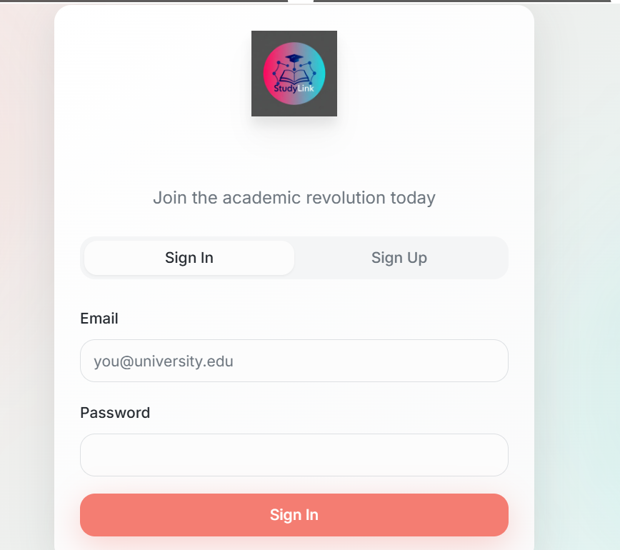
Figure 5: User Login Screen for STUDYLINK

4.1.2 New Assignment Submission Form
This screen allows the user to input details for a new assignment or essay. The student records the subject, topic, required word count, and submission deadline. Once submitted, the request is stored in the database and can be viewed on the user's dashboard.
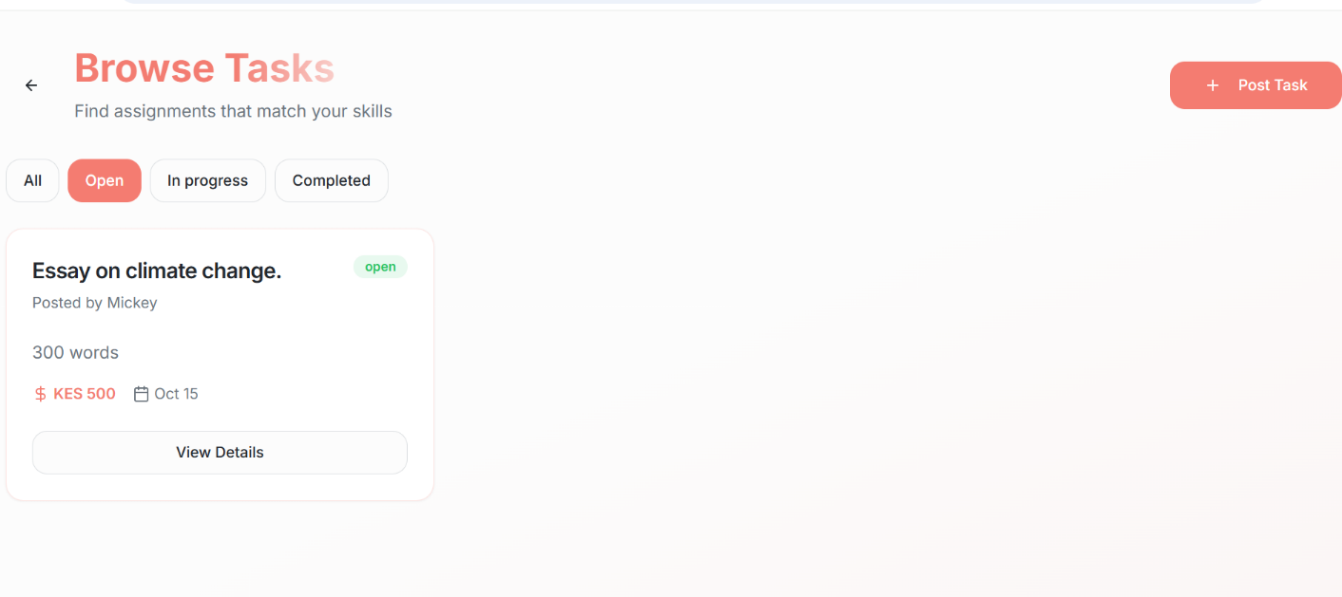
Figure 6: New Assignment Submission Form for STUDYLINK

4.1.3 Dashboard Screen
The dashboard displays all active and completed assignments, essays, and writing tasks that have been entered into the system. It shows the task status, deadline, and assigned writer in a clear table format, allowing the user to easily view, monitor, and track their writing tasks over time.
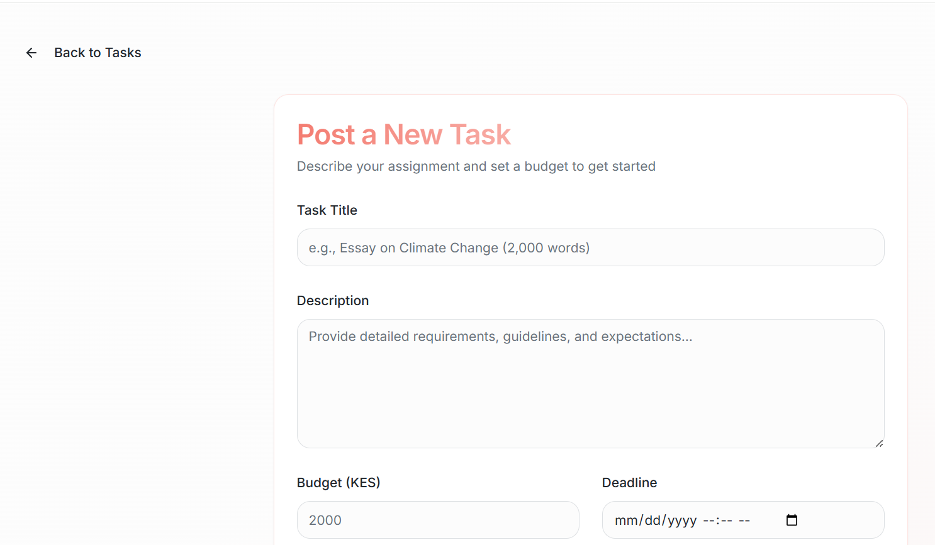
Figure 7: Student Dashboard Screen for STUDYLINK

4.2 Description of the Implementation

4.2.1 Hardware Specification
These are the minimal configurations for a system to run the platform efficiently. It is recommended that the computer should have at least 8GB of storage space and 2GB of RAM. The system requires a quad-core processor to handle concurrent user sessions and writing task processing. The main application and database will be hosted on a cloud server for 24/7 availability.

4.2.2 Software Specification
The STUDYLINK Online Writing Platform has been created to run on a web-based environment using PHP, MySQL, HTML, and CSS. It is hosted on a live server and depends on a stable internet connection to function properly.

4.3 Description of Testing and Results

4.3.1 System Testing
The STUDYLINK platform was tested using the black-box method. This type of software testing checks whether the system meets its functional requirements. It is an external method that compares the requirements specification against the final system functionality.

Testing and Data results
The table below shows how the functional requirements of the system were tested:
Module | Test carried out | Result of the test
User Login | Checks if system allows valid login | Username needed.
User Login | Check login with invalid credentials | Username does not exist.
Assignment Submission | Enter valid task details | Data saved successfully.
Dashboard Display | Check if submitted task appears on the dashboard | Data displayed correctly.

Table 1: Testing and Data Results

Non-functional requirements
Module | Test carried out | Result of test
Usability | Check if interface is user friendly | Interface is easy to navigate.
Reliability | Tests system behavior under normal use | No crashes or errors occurred
Performance | Measures response time for actions | Fast and responsive.
Security | Attempt access without login | Access denied.
Maintainability | Make minor code updates | System continued functioning

Table 4 2: Non-functional requirements

4.4 Description of results
The tests carried out on the system checked both the functional and non-functional requirements, ensuring optimal system functionality. The system performance was at optimum, with the processing power being quite responsive and rapid. The tests were carried out once the system had been fully developed.

CHAPTER FIVE:

CONCLUSION AND RECOMMENDATION

5.0 Introduction
This chapter presents the final conclusions drawn from the entire project regarding the development and evaluation of the StudyLink platform. It summarizes the findings in relation to the initial objectives and provides specific recommendations for the system's utilization, maintenance, and future expansion. This section also outlines potential areas for further work that can be undertaken to enhance the system's capabilities and reach.

5.1 Conclusion
The overarching goal of this study—to design, develop, and evaluate the StudyLink Online Platform to connect university students with flexible side-job opportunities—has been successfully achieved. The system was developed to solve the critical challenge of the lack of a systematic, secure, and student-centric platform for side employment, which leads to issues like time conflicts and exposure to unreliable opportunities. Through the implementation of a user-friendly interface, authenticated access, and a dynamic job-filtering mechanism, StudyLink now enables students to securely find and manage daily side jobs that align with their specific academic schedules. By digitizing and centralizing this process, the system significantly improves students' time management, enhances their financial stability, and contributes positively to their overall work-study balance and professional development.

5.2 Recommendation
Institutional Adoption: It is strongly recommended that the platform be adopted by university administration or the relevant student affairs/career office as the official centralized hub for student-freelancing and side-job activities.
User Training and Onboarding: Comprehensive training and user manuals should be provided to both students and prospective clients/employers to ensure high digital literacy.
External Support and Vetting: Support from government agencies or local business development organizations should be sought to increase awareness among employers.

5.3 Future Works
The successful completion of this project provides a robust foundation upon which the following future enhancements and expansions can be developed: Mobile App Integration: The system could be expanded to include a dedicated StudyLink mobile application to improve accessibility,
Automated Features: Integration of advanced features such as automated job matching based on student skills and availability using machine learning, and automated report generation for tracking student employment trends, should be considered.
Financial Module: Implementation of a secure, integrated payment or escrow service to facilitate secure financial transactions directly within the platform, thereby offering an end-to-end service for both students and clients.\

REFERENCES
Al-Harthi, H. B., & Al-Salti, Z. H. (2018). Impact of Time Management on Academic Performance of University Students. International Journal of Research in Science and Engineering, 4(3), 1-10.
Baddeley, A. D. (1992). Working memory. Science, 255(5044), 556-559.
Cooper, P., & Hedges, S. (2019). The Ethics of AI in Education: Tools for Academic Integrity and Support. Journal of Higher Education and Policy, 14(2), 45-61.
Hattie, J., & Yates, G. C. (2014). Visible Learning and the Science of How We Learn. Routledge.
Kiptoo, J. C. (2020). Student Employment and its Effects on Academic Performance in Online Learning Environments. African Journal of Online Education, 12(1), 105-122.
Organisation for Economic Co-operation and Development (OECD). (2023). Education at a Glance 2023: OECD Indicators. OECD Publishing.
Pallant, J. (2016). SPSS Survival Manual: A Step by Step Guide to Data Analysis using IBM SPSS. Allen & Unwin.
Sweller, J. (2010). Element interactivity and intrinsic, extraneous, and germane cognitive load. Educational Psychology Review, 22(4), 469-478.
Zimmerman, B. J. (1990). Self-regulated learning and academic achievement: An overview. Educational Psychologist, 25(1), 3-17.

APPENDICES

APPENDIX A: CODE REPOSITORY AND TECHNICAL ARTIFACTS
This appendix serves as a direct reference for accessing the comprehensive technical materials and source code developed for the StudyLink Project. All project files are maintained in a secure, version-controlled repository to facilitate transparency, review, and future maintenance.

GITHUB RESPIROTORY LINK ACCES
The full source code for the StudyLink Project can be accessed directly using the URL provided below: https://github.com/cynthia-jeruto/studylink

